CSIT314 Software Development Methodologies - Group Project

Sprint 3 - US32: View IDP
Interior Design Platform - Customer
All diagrams were drawn in draw.io. Open "US32 View IDP.drawio" in this folder to edit them - each diagram is its own page in that file. The exported images are in the "diagrams" folder.

Assumptions
- The system is the Interior Design Platform from the project specification. Sprint 3 covers the Interior Designer's current IDP stories (US20 - US24) and the Customer's log in, search IDPs, view IDP and log out stories (US30 - US32, US36).
- We follow B-C-E: the actor only talks to the boundary (page), the boundary only talks to the controller, and the controller works with the entity classes. There is one controller per use case.
- Who checks what: the page trims the keyword (it is only kept for Back to search) and works out countView. ViewIDPController.viewIDP(idpId, countView) just calls IDP.viewIDP(idpId, countView) and returns the IDP or None - no checks and no dict. The entity checks the database state: the IDP and its category must be Active.
- Being logged in as a Customer (UC30) is the precondition, so the page and the diagrams don't check the customer again (no CustomerLoginController, no customerId). customerLoginRequired in app.py only sends someone with no session to /customer/login.
- A customer can view any Active IDP in an Active category - Current or Past, from any designer (the same IDPs as US31). A missing, Suspended or hidden-category IDP shows "This IDP is not available." (HTTP 404).
- The designer's company information belongs to US15, so the page borrows ViewCompanyProfileController.viewCompanyProfile(idp.designerId) - the same way US9 borrows US4's controller. It uses the IDP's saved designerId, never a value from the URL. If the designer has no Active company profile, the IDP is still shown with "Designer information is not currently available."
- Each view is counted for the designer's view statistics (US37, US46 - US48): IDP.viewIDP() inserts one idp_view row when the IDP is found and countView is True. When US33's Save sends the customer back to this page (/customer/idps/<idpId>?saved=1) the route passes saved = True, so countView = not saved is False and that reload is not counted.
- The page shows the title, category, location (if any), project type and the full description (line breaks kept), plus the company name, description and services. No account details or private contact details are shown.
- The Save IDP button (US33) is always shown; US33 handles an IDP that is already saved. Back to search keeps the trimmed keyword and always goes to the US31 search page.

1. User story
Story ID | US32
User story | As a customer, I want to view an IDP so that I can see its details and learn about the designer's work.
Actor | Customer
Priority | Medium
Story points (estimate) | 2
Acceptance criteria | 1. Given I am logged in as a customer, when I click View on a search result (or open its link), then I see the IDP's title, category, location, project type and full description.  2. I also see the designer's company name, description and services; if the designer has no Active company profile I see "Designer information is not currently available."  3. Given the IDP is missing, Suspended or in a Suspended category, then I see "This IDP is not available." (HTTP 404).  4. Each time I open an IDP it counts as one view for the designer's statistics; coming back to the page after clicking Save IDP doesn't count.  5. The Save IDP button is always shown, and Back to search returns to my search with the same keyword.  6. Given I am not logged in, when I open an IDP link, then I am sent to the customer login page.
Tasks | #146 Develop IDP details page and retrieval logic  #156 Draw Use Case Diagram and Description  #166 Draw BCE and Sequence Diagram  #175 Design Wireframe  #185 Write and Execute Test Cases

2. Use case diagram
The user story becomes one use case, UC32 View IDP. The Customer is the only actor. Being logged in (UC30) is the precondition; searching (UC31) is one way to pick an IDP, so it is not an included use case.
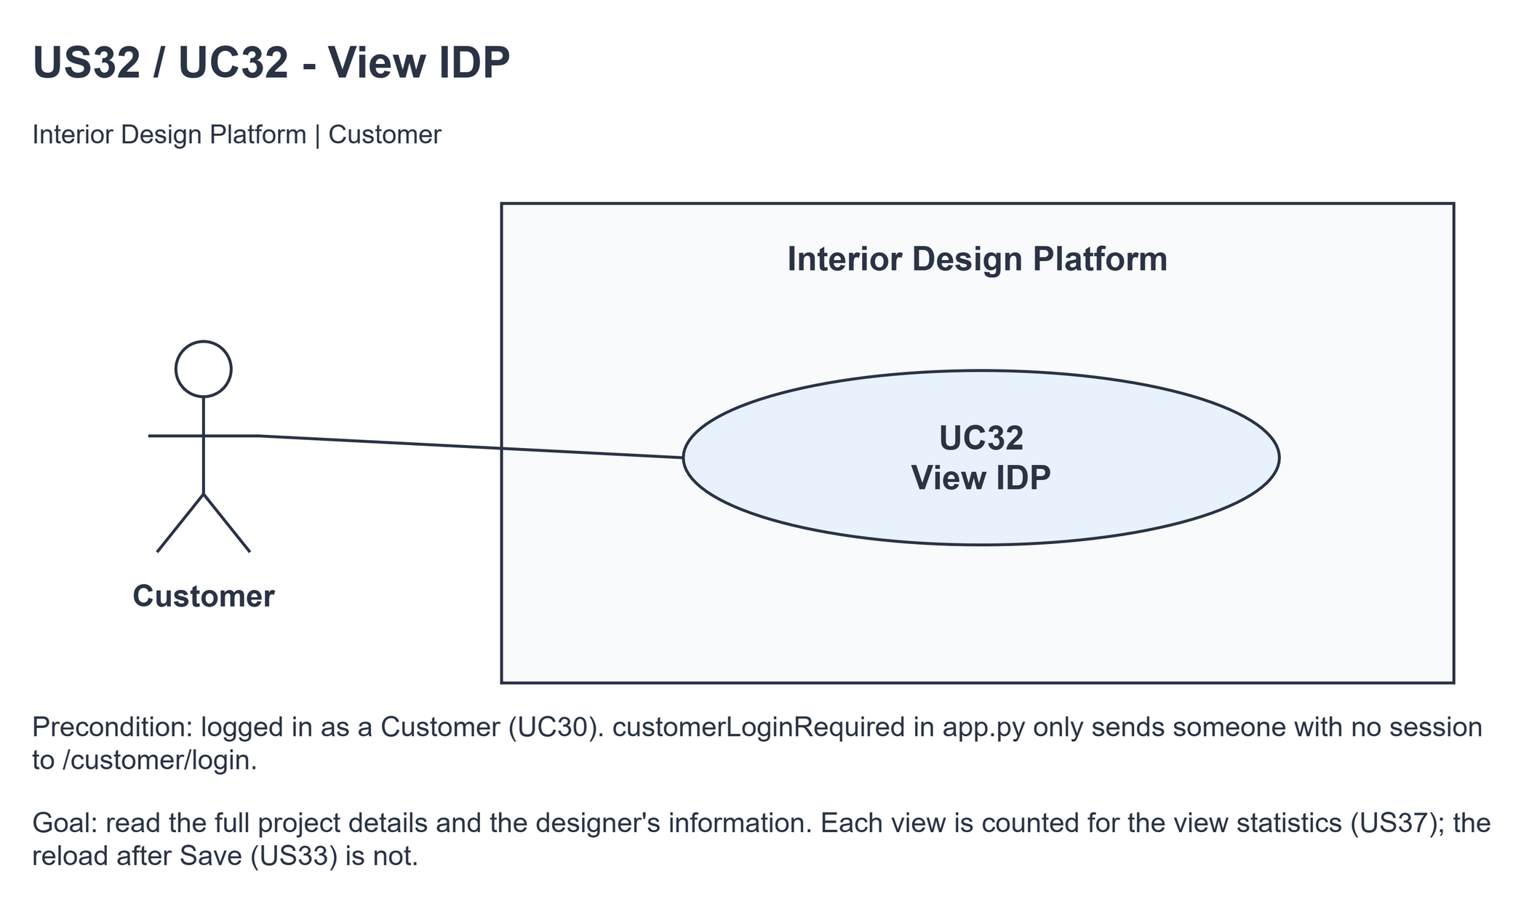
Figure 1: Use case diagram for US32 View IDP

3. Use case description
Use case | UC32 View IDP
Actor | Customer
Brief description | The Customer opens an IDP to read its full details and learn about the designer's work.
User story | US32: As a customer, I want to view an IDP so that I can see its details and learn about the designer's work.
Preconditions | The Customer is logged in (UC30).
Trigger | The Customer clicks View on a US31 search result or opens an IDP's link.
Basic flow | 1. The Customer clicks View on an IDP.  2. The system trims the search keyword (kept for Back to search).  3. The system finds the IDP if it and its category are Active, and counts one view for it.  4. The system gets the designer's company profile (US15).  5. The system shows the IDP details, the designer's company name, description and services, the Save IDP button and Back to search.
Alternative flows | 3a. The IDP is missing, Suspended or its category is Suspended: the system shows "This IDP is not available." (HTTP 404) with Back to search. No view is counted.  3b. The page was opened by US33's Save (?saved=1): the IDP is shown but no view is counted.  4a. The designer has no Active company profile: the system shows the IDP with "Designer information is not currently available."
Postconditions | The IDP details are shown and one view is counted (except after Save), or the unavailable message is shown. Nothing else is changed.

4. Wireframes
The wireframes were drawn in draw.io. They are low-fidelity: they show the layout and the flow, not the final colours. They follow customerBase.html, customerSearchIDPs.html, customerViewIDP.html, customerIDPNotFound.html and static/style.css. The Save IDP button (US33) is always shown on the details page.

4a - Select an IDP from search
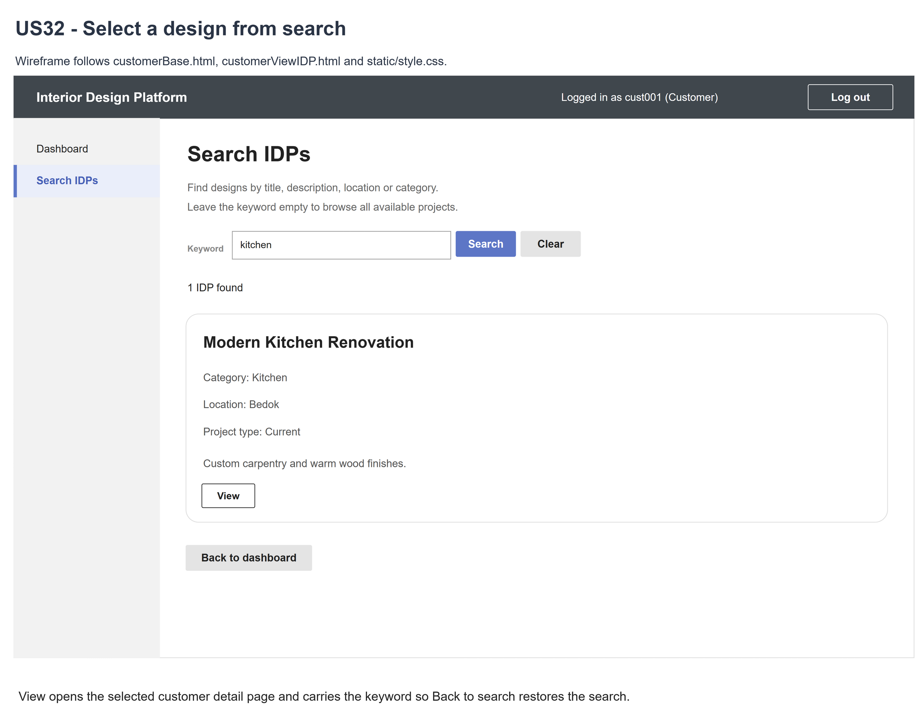
Figure 2: Wireframe 4a - Select IDP (US32)

4b - IDP details and designer information
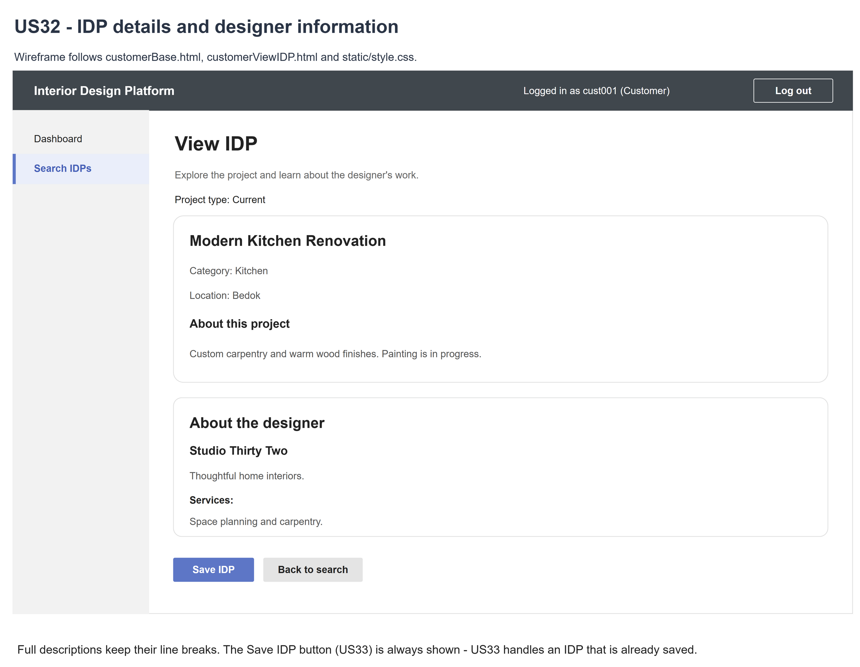
Figure 3: Wireframe 4b - IDP details (US32)

4c - Designer information unavailable
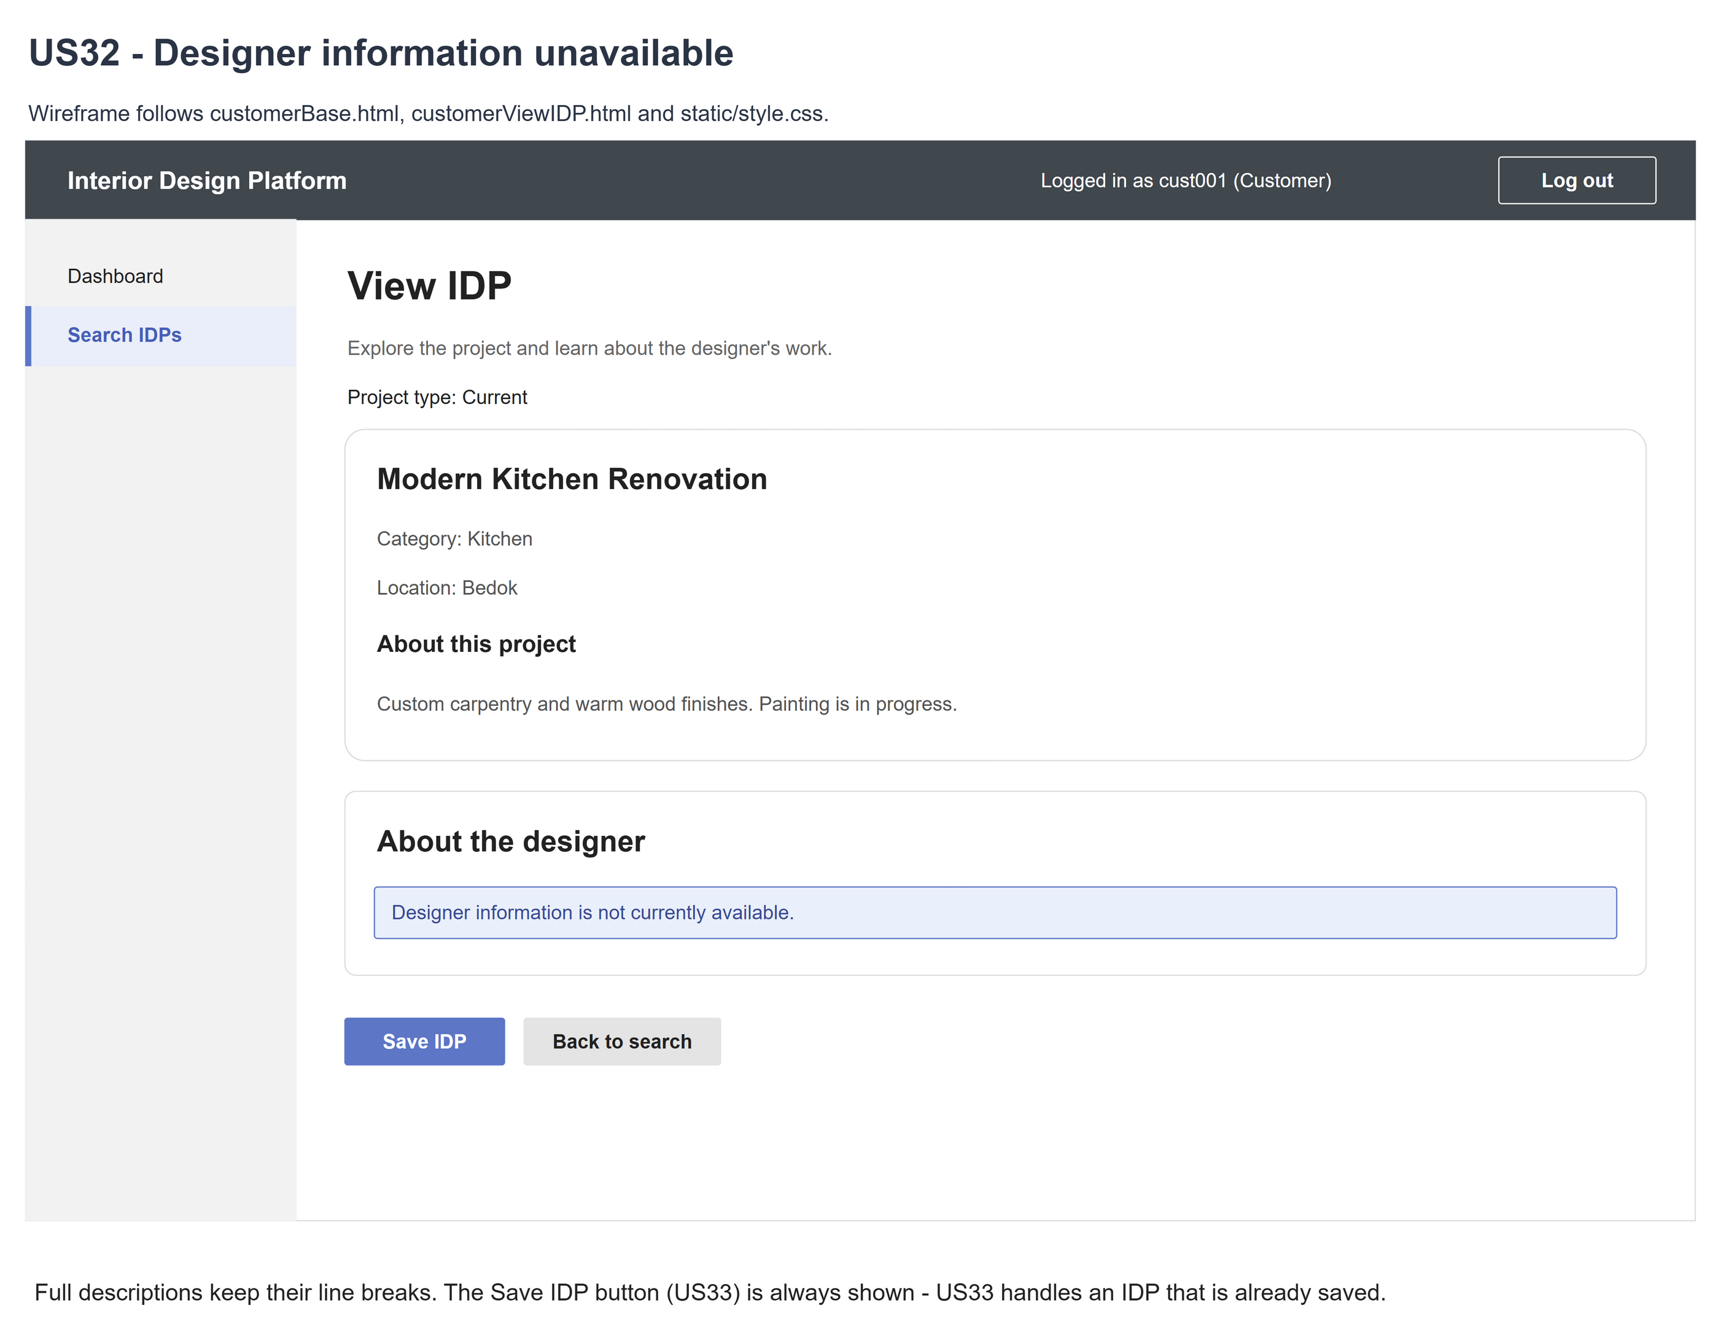
Figure 4: Wireframe 4c - Designer information unavailable (US32)

4d - IDP unavailable
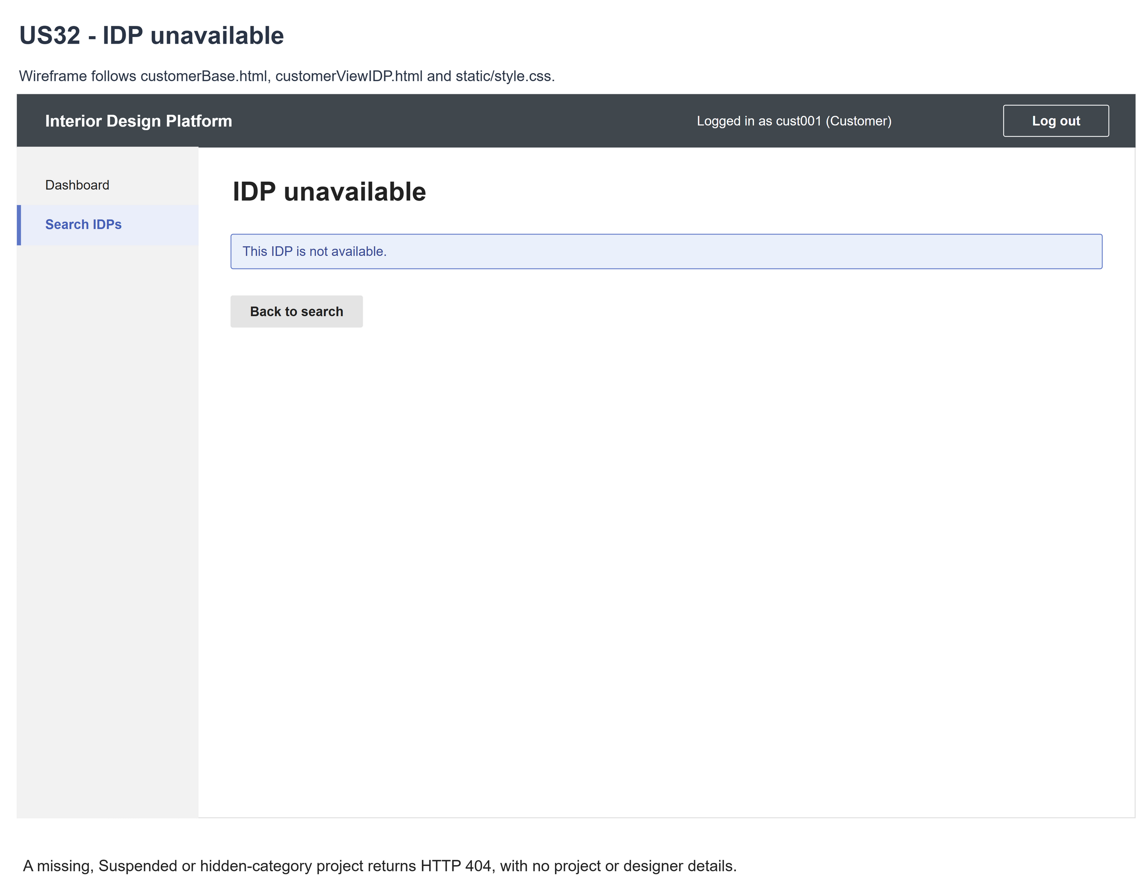
Figure 5: Wireframe 4d - IDP unavailable (US32)

5. B-C-E class diagram
The solid lines mean the boundary calls a controller - its own, and US15's borrowed one for the designer information. The dashed line means the controller uses the entity class. Only the operations needed for this use case are shown, with the same names as the code.
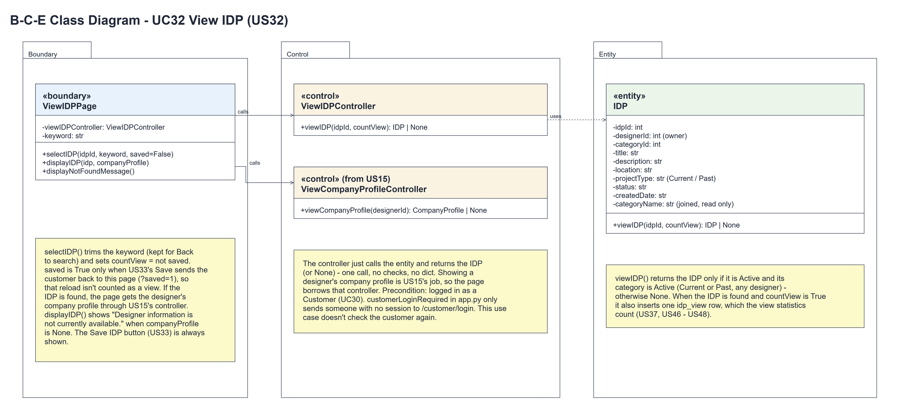
Figure 6: B-C-E class diagram for US32 View IDP
Layer | Class | What it does
Boundary | ViewIDPPage | The IDP details page. selectIDP(idpId, keyword, saved) trims the keyword, sets countView = not saved and calls viewIDP(). If the IDP is found it borrows US15's controller for the company profile and calls displayIDP(idp, companyProfile); otherwise displayNotFoundMessage() (HTTP 404).
Control | ViewIDPController | Controller for UC32. viewIDP(idpId, countView) just calls IDP.viewIDP(idpId, countView) and returns the IDP or None - no checks, no dict.
Control | ViewCompanyProfileController (from US15) | viewCompanyProfile(designerId) - the page uses it to show the designer's Active company profile (or None).
Entity | IDP | The only entity. viewIDP(idpId, countView) returns the IDP if it and its category are Active (any designer, Current or Past), otherwise None. When it is found and countView is True it inserts one idp_view row (view statistics, US37).

6. Sequence diagram
The sequence diagram follows UC32. The page trims the keyword and sets countView = not saved (saved is True only when US33's Save sends the customer back with ?saved=1). The controller makes one call to IDP.viewIDP(idpId, countView), which returns the IDP or None and records the view. The alt shows the two endings: the page borrows US15's controller for the company profile and shows the details (with the fallback text when there is no company profile), or the "not available" page (alternative flow 3a).
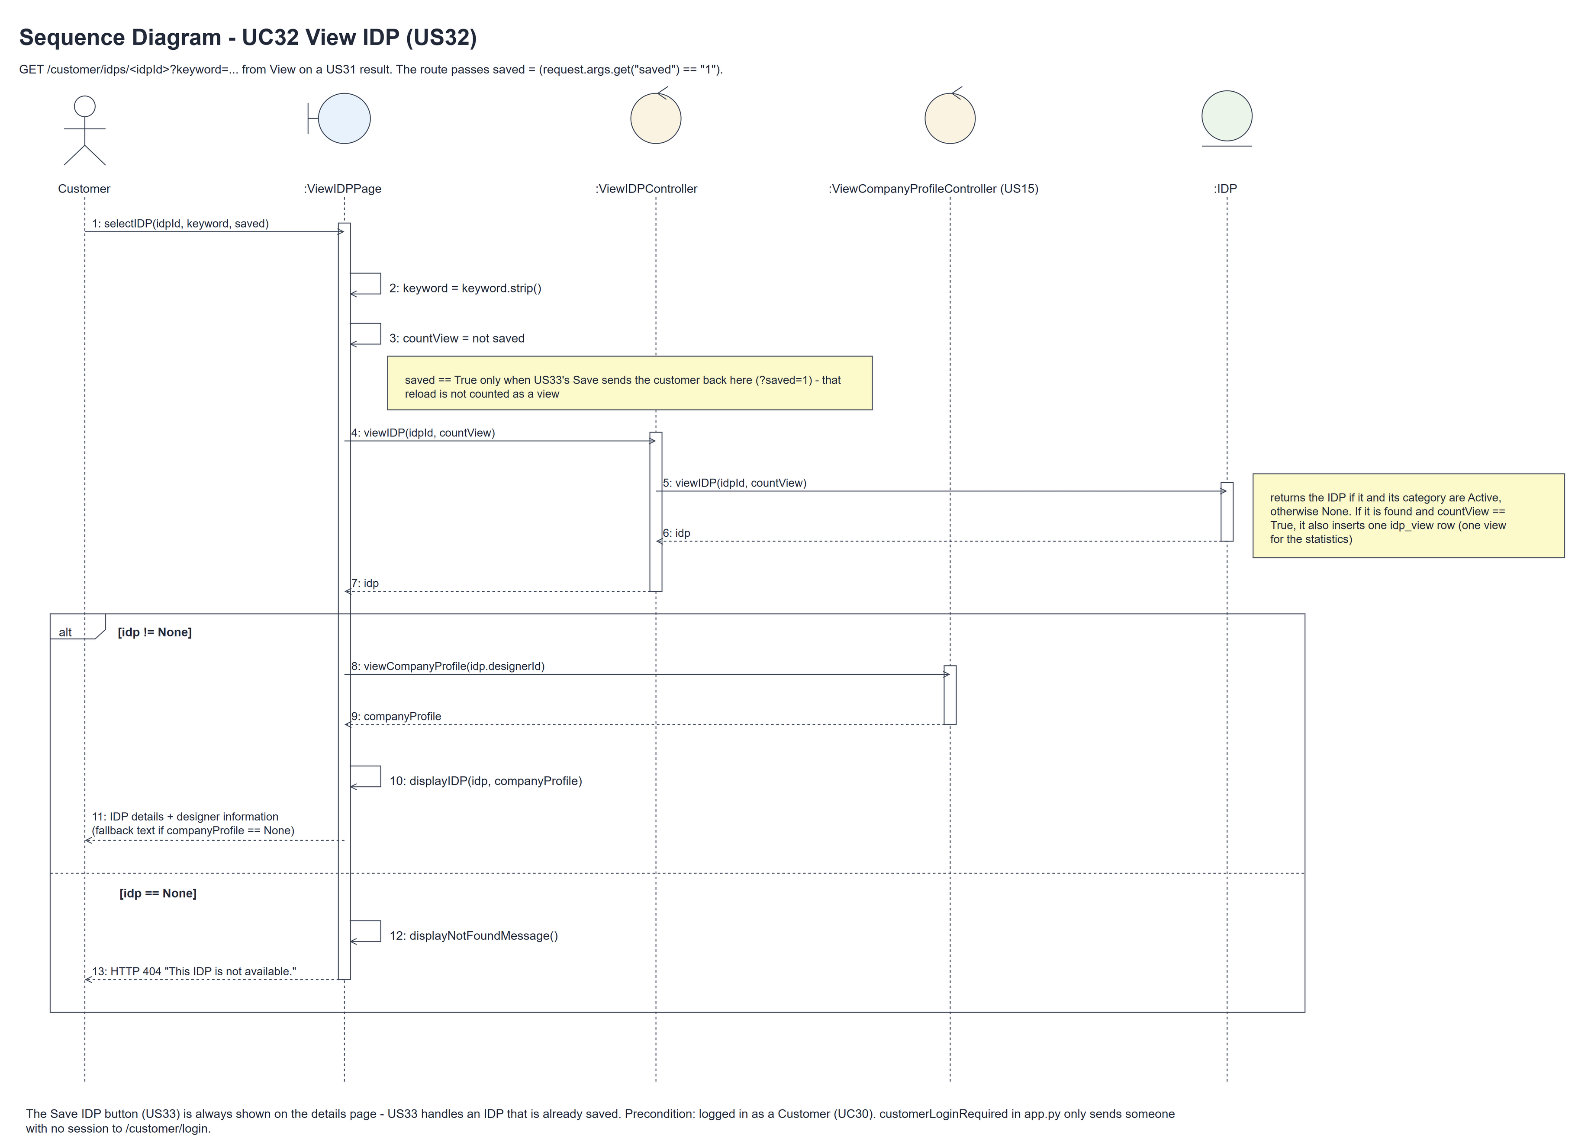
Figure 7: Sequence diagram for UC32 View IDP

7. Test cases
Test data used below (same as the test file): two interior designers with Current, Past, Suspended and hidden-category IDPs, an Active, Suspended or missing company profile, and the customer cust001 / Cust@123. Tests use an isolated database.

7a. System test cases (black box)
Equivalence partitioning and boundary value analysis were used to pick the test data. Fill in "Actual result" and "Pass/Fail" after running each test.
Test ID | Scenario | Prerequisites | Test steps | Test data | Expected result | Actual result | Pass / Fail
TC32.1 | View from search | Customer has results. | Select View. | Visible IDP | Correct full details shown.
TC32.2 | Current / Past | Both project types exist. | Open each IDP. | Current; Past | Both visible types supported.
TC32.3 | Full description | Long multiline content. | Open IDP. | Up to 2000 chars | Full text and line breaks retained.
TC32.4 | Designer information | Active company exists. | Open owner's IDP. | Company fields | Name, description, services shown.
TC32.5 | Company unavailable | Missing/Suspended company. | Open visible IDP. | No Active company | Project remains; fallback message.
TC32.6 | Unavailable IDP | Hidden/missing project. | Open direct/stale link. | Suspended; hidden category | 404; no project/designer details.
TC32.7 | Not logged in | Signed out. | Open an IDP link. | No session | Sent to the customer login page.
TC32.8 | View is counted | Customer logged in. | Open a visible IDP; check the designer's view statistics (US37). | Visible IDP | One more view is counted for that IDP.
TC32.9 | Back to search | Filtered search. | View; Back to search. | kitchen | Keyword retained on US31 route.
TC32.10 | Fresh content | Customer can view. | Update/hide data; reload. | Saved changes | Current content or 404.
TC32.11 | Safe display | Script text exists. | View project/company. | HTML/script text | Escaped text; no execution.
TC32.12 | Save doesn't count a view | Customer logged in. | Open an IDP, click Save IDP (US33), check the view statistics. | Visible IDP | Opening counts one view; the page shown after Save (?saved=1) adds no view. | Opening the IDP counted one view. The page after Save, opened with ?saved=1, added no view. | Pass
TC32.13 | Save button always shown | The customer already saved the IDP (US33). | Open the IDP. | Saved IDP | The Save IDP button is still shown; clicking it shows US33's message. | The Save IDP button was shown; clicking it showed "This IDP is already in your saved list". | Pass

7b. Unit test cases (for TDD)
These are written before the code (test-driven development) and run with pytest (python -m pytest). They cover normal inputs, abnormal inputs and boundary values. Each one matches a test function in tests/test_us32_viewIDP.py (UT32.1 is test_ut32_1_...). Controller means ViewIDPController; Boundary means ViewIDPPage. "Pass" is from the pytest run on 10 November 2026.
Test ID | Class and method | Input / setup | Expected output | Type | Pass / Fail
UT32.1 | IDP.viewIDP() | Visible Current IDP, countView False. | The IDP with its joined category. | Normal | Pass
UT32.2 | IDP.viewIDP() | Visible Past IDP. | The Past IDP is returned. | Normal | Pass
UT32.3 | IDP.viewIDP() | Another designer's visible IDP. | Returned - there is no owner filter. | Normal | Pass
UT32.4 | IDP.viewIDP() | Suspended / hidden-category / missing IDP, countView True. | None; no idp_view row added. | Abnormal | Pass
UT32.5 | IDP.viewIDP() | Negative/zero/missing/SQL-like ID. | None; no bypass. | Boundary | Pass
UT32.6 | Controller.viewIDP() | IDP.viewIDP stubbed; (idpId, True) | Called once with (idpId, True); the IDP is returned unchanged (no dict, no company lookup). | Normal | Pass
UT32.7 | Boundary.selectIDP() | Visible IDP whose designer has no company profile. | US15's viewCompanyProfile() returns None; the IDP is still shown. | Normal | Pass
UT32.8 | Boundary.selectIDP() | The designer's company profile is Suspended. | US15's controller returns None; the fallback text is shown. | Abnormal | Pass
UT32.9 | Controller.viewIDP() | Any idpId. | It doesn't check the customer (no customerId, no error raised) - one entity call. | Normal | Pass
UT32.10 | Boundary.selectIDP() | Hidden IDP. | viewIDP() returns None: US15's controller isn't called; HTTP 404. | Abnormal | Pass
UT32.11 | Boundary.selectIDP() | Another designer's IDP. | viewCompanyProfile() is called with idp.designerId (the saved owner). | Normal | Pass
UT32.12 | Boundary.selectIDP() | Normal GET of a visible IDP (no saved flag). | countView is True: exactly one idp_view row is added. | Normal | Pass
UT32.13 | Boundary.displayIDP() | Long project description + company. | Full text; relevant fields; no private data. | Normal | Pass
UT32.14 | customerLoginRequired (app.py) | GET an IDP, not logged in. | Redirects to /customer/login. | Abnormal | Pass
UT32.15 | View GET | Session made by another role's log in. | HTTP 200 - the role isn't checked again (being a customer is the precondition). | Boundary | Pass
UT32.16 | Boundary.displayNotFoundMessage() | Hidden/missing project with keyword. | 404; no details; retained return keyword. | Abnormal | Pass
UT32.17 | Route ID | Invalid/non-numeric/unknown IDs. | HTTP 404. | Boundary | Pass
UT32.18 | Designer fallback | No company profile. | 200; IDP remains; fallback message. | Normal | Pass
UT32.19 | Designer fallback | Suspended company profile. | 200; no hidden company data. | Abnormal | Pass
UT32.20 | US31 View / Back to search | Padded search keyword. | Correct ID link; trimmed keyword retained. | Normal | Pass
UT32.21 | Direct view | Past IDP; no keyword. | 200; working search return link. | Normal | Pass
UT32.22 | View after login | Account/profile/permission changed after logging in. | HTTP 200 - the role isn't checked again; the next customer login is refused. | Abnormal | Pass
UT32.23 | Stale search link | Suspend IDP or category. | HTTP 404 on detail request. | Abnormal | Pass
UT32.24 | Repeat view | Update description and services. | Latest saved values rendered. | Normal | Pass
UT32.25 | View query | Forged owner/ID/return URL. | Route ID/saved owner; fixed return route. | Abnormal | Pass
UT32.26 | Repeat views | Open 3 visible and 2 hidden IDPs; compare database dumps. | The only change is one idp_view row per visible IDP opened (3); hidden IDPs add none. | Normal | Pass
UT32.27 | HTTP methods | POST/PUT/PATCH/DELETE. | HTTP 405. | Abnormal | Pass
UT32.28 | Project/company/keyword text | Script and HTML strings. | Escaped output. | Abnormal | Pass
UT32.29 | Optional location | Empty location. | Location omitted; page remains 200. | Boundary | Pass
UT32.30 | Boundary.selectIDP() | ViewIDPController.viewIDP stubbed. | Called once with (idpId, countView) - no customerId, no second access check. | Normal | Pass
UT32.31 | Header | Logged in as cust001. | "Logged in as cust001 (Customer)" from the session (no account lookup). | Normal | Pass
UT32.32 | Back to search | Whitespace-only keyword. | All-results search return link. | Boundary | Pass
UT32.33 | IDP.viewIDP() | Visible IDP, countView False. | The IDP is returned; no idp_view row added. | Boundary | Pass
UT32.34 | Boundary.selectIDP() | GET /customer/idps/<idpId>?saved=1 (US33's redirect after Save). | The page is shown; saved = True so countView = False - no idp_view row. | Boundary | Pass
UT32.35 | Boundary.displayIDP() | IDP already saved by this customer. | The Save IDP button is still shown (no "Saved" state); US33 handles the duplicate. | Normal | Pass

